Carols on the Green


Sunday December 20th at 4pm

Come and sing your favourite carols and Christmas songs on the village green

Vote online for your favourite music and donate to the
Children’s hospice SW
Bring a lantern or a torch
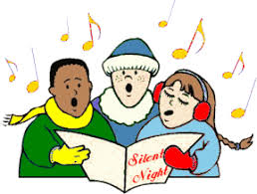
MUSIC


Socially distanced and covid –secure

Laughter
Download and print off the song sheets


Dress up in your favourite Christmas jumper
Bring a chair
And some hot chocolate
Wear your Rudolph antlers

Celebrate!

Add a touch of tinsel
Christmas Spirit

